**Year 2 Semester 1 (2025)**

IT2120 - Probability and Statistics Lab Sheet 08

Before starting the lab sheet, you need to create a folder in your desktop and save all your working inside the folder. Set the working directory to that folder using the following command:



**FacultyofComputing**

setwd("paste the path of the folder")

**Eg:-** setwd("D:\\2025 - Sem 2\\IT2120\\Lab Sessions\\Lab 08")

The nicotine contents, in milligrams for 40 cigarettes of a certain brand (population) were recorded.

1. Calculate population mean and variance of the dataset.

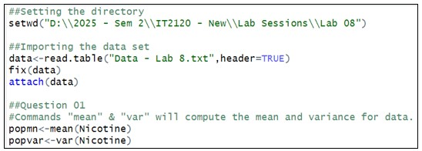

1. Get 30 random samples of size 5, with replacement and calculate sample mean and sample variance for each sample.

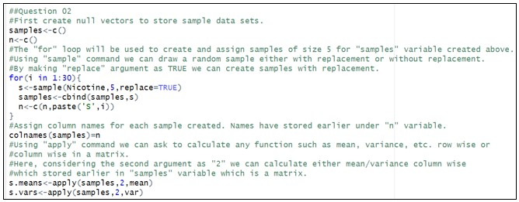

1. Calculate mean and variance of the Sample Means.

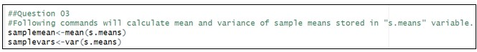

1. Compare and state relationship (if any) Population Mean and the Mean of Sample Means.

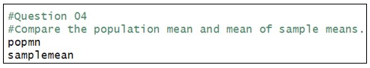

1. Compare and state relationship (if any) Population Variance and the Variance of Sample Means.

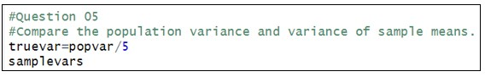

Use the Following Format:

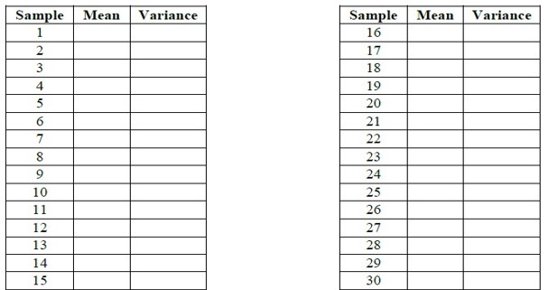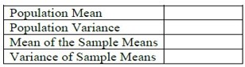

# Exercise

**Instructions**: Create a folder in your desktop with your registration number (Eg: “IT.......”). You need to save the R script file and take screenshots of the command prompt with answers and save it in a word document inside the folder. Save both R script file and word document with your registration number (Eg: “IT........”). After you finish the exercise, zip the folder and upload the zip file to the submission link.

1. Calculate the population mean and population standard deviation of the laptop bag weights.

1. Draw 25 random samples of size 6 (with replacement) and calculate the sample mean and sample standard deviation for each sample.

1. Calculate the mean and standard deviation of the 25 sample means and state the relationship of them with true mean and true standard deviation.

